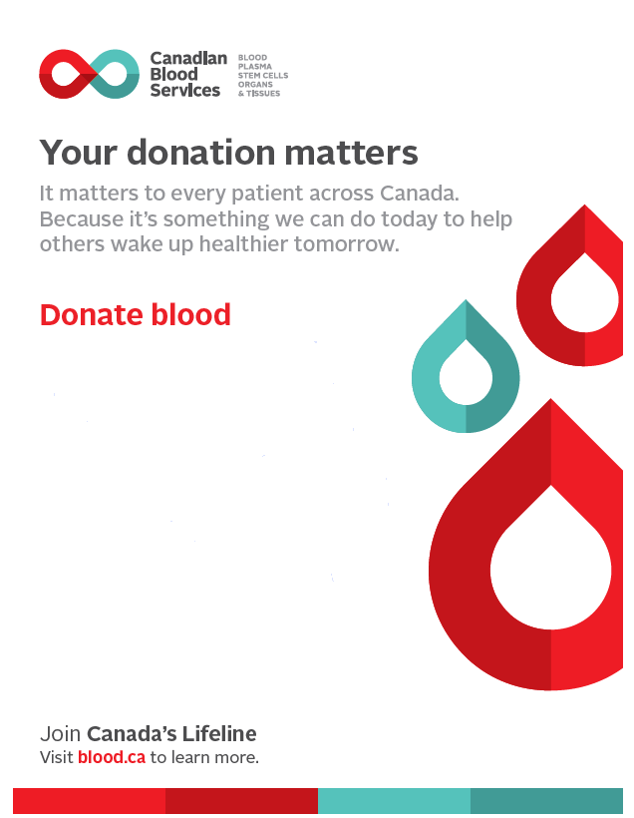

Port Alberni

Blood Donation Events

**July 26-28, 2022**

(Tuesday to Thursday)

2:00 p.m. to 6:45 p.m.

**Barclay Best Western Plus Hotel**

4277 Stamp Avenue

Scan QR code to book appointment:

|  |  |
| --- | --- |
|  |  |
|  |  |
|  |  |

Please check blood.ca or Giveblood app to book an appointment.  Donors who have current appointment will be contacted with the new site location.